|  |
| --- |
| EPAM Systems, RD Dep. |
| MTN.BI.08 Advanced Refresh Scenarios |

|  |  |  |  |  |  |
| --- | --- | --- | --- | --- | --- |
| REVISION HISTORY | | | | | |
| Ver. | Description of Change | Author | Date | Approved | |
| Name | Effective Date |
| 1.0 | Initial status | [Kiryl Bucha](mailto:Kiryl_Bucha@epam.com) | 12-JAN-2012 |  |  |
| 2.0 | Updated in accordance with renewed content | [Elias Nema](mailto:Elias_Nema@epam.com) | 20-JAN-2014 |  |  |
| 3.0 | Report | Aksana Kuratnik | 08-DEC-2017 |  |  |

Contents

1. Business Task – Performance of STAR Scheme 3

1.1. Prepare Report Layout 3

1.2. Compare Report Layout Performance 3

2. Advanced Loading 3

3. ETL Structure 3

# Business Task – Performance of STAR Scheme

## Prepare Report Layout

The Main Task is to create SQL for Report Layout that was developed in the concepts of your business in the last module (Use STAR schema objects for source of Data).

## Compare Report Layout Performance

The Main Task is to create summarize table with comparison Performance of next Report Layout:

* Advancing Grouping (GROUP BY GROUPING SETs – Lab Work 02)
* 3NF (Staging)
* Star Schema (Lab Work 11)

Task Results:

* Prepare Document with description of results.

# Advanced Loading

Implement Fact Table load with use of EXCHANGE PARTITION clause and logic of load for some rolling window period.

# ETL Structure

Create all scripts for ETL Process and store it on next structure:

* Instance name
* Schema name
* Tables
* T_.... (Object name)
* -scripts
* T_.... (Object name)
* -scripts
* Views
* VW_...

**Performance of the 3NF Layer:**

This script provides us with opportunity to analyze company’s sales in the previous year with grouping by quarter and month.

**SELECT DECODE(GROUPING_ID(TO_CHAR(order_dt,'YYYY'), upper(TO_CHAR(order_dt,'YYYY'))**

**|| '-'**

**|| 'Q'**

**|| TO_CHAR(order_dt,'Q'), upper(TO_CHAR(order_dt,'YYYY')**

**|| '-'**

**|| TO_CHAR(order_dt,'Mon') ), order_dt), 7, 'GRAND TOTAL FOR '**

**|| TO_CHAR(order_dt,'YYYY'), ' ') AS YEAR,**

**DECODE(GROUPING_ID(TO_CHAR(order_dt,'YYYY'), upper(TO_CHAR(order_dt,'YYYY'))**

**|| '-'**

**|| 'Q'**

**|| TO_CHAR(order_dt,'Q'), upper(TO_CHAR(order_dt,'YYYY')**

**|| '-'**

**|| TO_CHAR(order_dt,'Mon') ), order_dt), 3, 'GRAND TOTAL FOR '**

**|| upper(TO_CHAR(order_dt,'YYYY'))**

**|| '-'**

**|| 'Q'**

**|| TO_CHAR(order_dt,'Q'), ' ') AS quarter,**

**DECODE(GROUPING_ID(TO_CHAR(order_dt,'YYYY'), upper(TO_CHAR(order_dt,'YYYY'))**

**|| '-'**

**|| 'Q'**

**|| TO_CHAR(order_dt,'Q'), upper(TO_CHAR(order_dt,'YYYY')**

**|| '-'**

**|| TO_CHAR(order_dt,'Mon') ), order_dt), 1, 'GRAND TOTAL FOR '**

**|| upper(TO_CHAR(order_dt,'YYYY')**

**|| '-'**

**|| TO_CHAR(order_dt,'Mon') ), ' ') AS MONTH,**

**DECODE(GROUPING(order_dt), 1, ' ', order_dt) AS DAY,**

**TO_CHAR(SUM(sum_of_payment), '999,999,999,999') AS sales**

**FROM ce_orders dt**

**WHERE TO_CHAR(order_dt,'YYYY') = 2016**

**GROUP BY ROLLUP( TO_CHAR(order_dt,'YYYY'), upper(TO_CHAR(order_dt,'YYYY'))**

**|| '-'**

**|| 'Q'**

**|| TO_CHAR(order_dt,'Q'), upper(TO_CHAR(order_dt,'YYYY')**

**|| '-'**

**|| TO_CHAR(order_dt,'Mon') ), order_dt );**

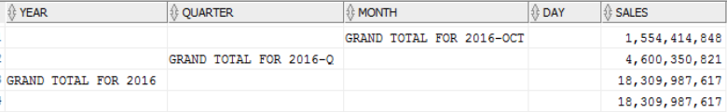

EXPLAIN PLAN for the script:

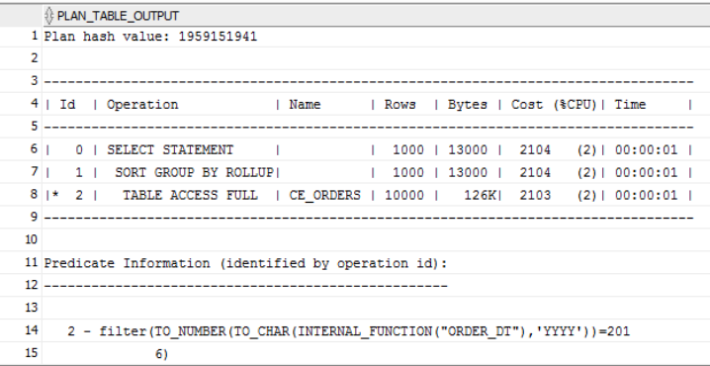

**Performance of the DM Layer:**

**SELECT DECODE(GROUPING_ID(TO_CHAR(event_dt,'YYYY'), upper(TO_CHAR(event_dt,'YYYY'))**

**|| '-'**

**|| 'Q'**

**|| TO_CHAR(event_dt,'Q'), upper(TO_CHAR(event_dt,'YYYY')**

**|| '-'**

**|| TO_CHAR(event_dt,'Mon') ), event_dt), 7, 'GRAND TOTAL FOR '**

**|| TO_CHAR(event_dt,'YYYY'), ' ') AS YEAR,**

**DECODE(GROUPING_ID(TO_CHAR(event_dt,'YYYY'), upper(TO_CHAR(event_dt,'YYYY'))**

**|| '-'**

**|| 'Q'**

**|| TO_CHAR(event_dt,'Q'), upper(TO_CHAR(event_dt,'YYYY')**

**|| '-'**

**|| TO_CHAR(event_dt,'Mon') ), event_dt), 3, 'GRAND TOTAL FOR '**

**|| upper(TO_CHAR(event_dt,'YYYY'))**

**|| '-'**

**|| 'Q'**

**|| TO_CHAR(event_dt,'Q'), ' ') AS quarter,**

**DECODE(GROUPING_ID(TO_CHAR(event_dt,'YYYY'), upper(TO_CHAR(event_dt,'YYYY'))**

**|| '-'**

**|| 'Q'**

**|| TO_CHAR(event_dt,'Q'), upper(TO_CHAR(event_dt,'YYYY')**

**|| '-'**

**|| TO_CHAR(event_dt,'Mon') ), event_dt), 1, 'GRAND TOTAL FOR '**

**|| upper(TO_CHAR(event_dt,'YYYY')**

**|| '-'**

**|| TO_CHAR(event_dt,'Mon') ), ' ') AS MONTH,**

**DECODE(GROUPING(event_dt), 1, ' ', event_dt) AS DAY,**

**TO_CHAR(SUM(total_cost), '999,999,999,999') AS sales**

**FROM fct_orders dt**

**WHERE TO_CHAR(event_dt,'YYYY') = 2016**

**GROUP BY ROLLUP( TO_CHAR(event_dt,'YYYY'), upper(TO_CHAR(event_dt,'YYYY'))**

**|| '-'**

**|| 'Q'**

**|| TO_CHAR(event_dt,'Q'), upper(TO_CHAR(event_dt,'YYYY')**

**|| '-'**

**|| TO_CHAR(event_dt,'Mon') ), event_dt );**

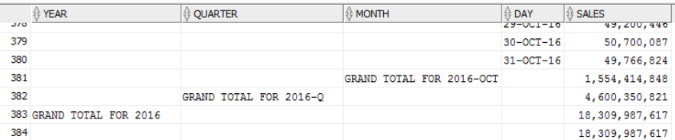

EXPLAIN PLAN for the script:

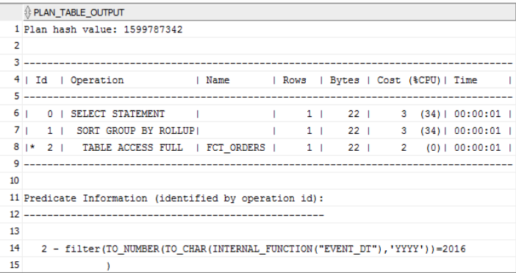

**Comparison of the results:**

**3NF Layer:**



**DM Layer:**



**The comparison of the result shows that the cost of the script from 3NF Layer is much more than the cost of the script of the DM Layer.**

**ETL Structure:**

